

**BITI 3533**

**AI PROJECT MANAGEMENT**

**SEM 1 2020/2021**

Assignment 2: AI Project WBS

Fake News Detection

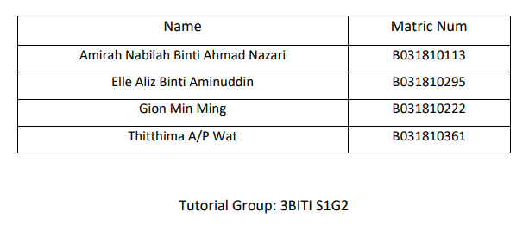

**WORK BREAKDOWN STRUCTURE (WBS)**

PROJECT TITLE: Fake News Detection

PROJECT MANAGER: Elle Aliz Binti Aminuddin

|  |  |
| --- | --- |
| **Contents** | |
| Outline View | 2 |
| Hierarchical Structure |  |
| Tabular View |  |
| Tree Structure View |  |
| WBS Dictionary |  |
| Glossary of Terms |  |

**Outline View**

Fake News Detection

1. **Planning**

1.1 Develop Project Charter

1.2 Define System Approach and Measurement

1.3 Identify Data Source

1.4 Milestone 1

**2. Design**

2.1 Data Management

2.1.1 Web Scraping

2.1.2 Data Wrangling

2.1.3 Data Preparation

2.2 Exploratory Data Analysis (EDA)

2.3 Milestone 2

**3. Development**

3.1 Modelling

3.1.1 Build Models

3.1.2 Train Data

3.1.3 Test Data

3.2 Analyze Data Trend

* 1. Milestone 3

**4. Planning**

4.1 Test Accuracy of Data

4.1.1 Inferences and Interpretations of Results

* 1. Analyze Results

4.3 Debug and Correction

4.4 Milestone 4

**5. Implementation**

5.1 Deploy System

5.2 Documentation

5.3 Summary and Presentation

Tabular View

